Caching, Redis/Memcached,
Eviction Strategies & Circular DLL
Interview Preparation — Q&A Guide

Q1. What is caching? Explain its usage with different use cases like computer organisation and web apps.
Answer:
Caching is the technique of storing a copy of frequently or recently accessed data in a smaller, faster storage layer so that future requests for that data can be served quickly, instead of repeatedly recomputing it or fetching it from a slower source (disk, database, network, or main memory).
It works because of the principle of locality of reference:
- Temporal locality — recently accessed data is likely to be accessed again soon.
- Spatial locality — data near recently accessed data is likely to be accessed soon too.
1. Caching in Computer Organisation
At the hardware level, caching bridges the huge speed gap between the CPU and main memory (RAM).
- CPU has L1, L2, and L3 caches built from fast SRAM, placed between the CPU core and RAM.
- L1 is smallest & fastest (per-core), L2 is larger but slightly slower, L3 is shared across cores and largest among the three.
- Data is moved in fixed-size blocks called cache lines; hardware uses mapping techniques — direct-mapped, fully associative, or set-associative — to decide where a block goes.
- A cache hit means data is found in the cache (fast); a cache miss means it must be fetched from a slower level, incurring a bigger delay.
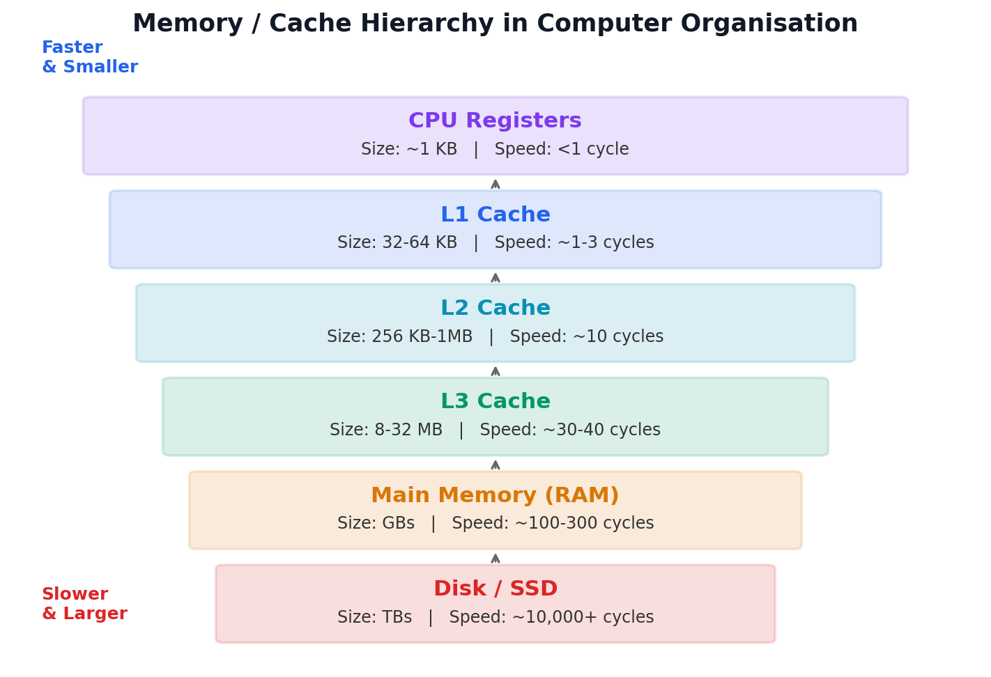
Fig 1: Memory hierarchy — cache sits between the CPU and RAM/Disk
2. Caching in Web Applications
In web systems, caching reduces database load, network latency, and server computation, improving scalability.
- Browser cache — stores static assets (CSS, JS, images) locally so repeat page loads are faster.
- CDN cache — edge servers geographically close to users cache static/dynamic content to cut network latency.
- Application-level cache — tools like Redis or Memcached store computed results, session data, or API responses in memory.
- Database query cache — avoids re-running expensive queries by storing recent result sets.
Example: An e-commerce homepage that shows "trending products" doesn't need to hit the database on every request — the result can be cached for a few minutes since it doesn't change every second.
💡 Interview Tip: Always mention the trade-off: caching improves speed but introduces the challenge of cache invalidation ("there are only two hard things in computer science: cache invalidation and naming things").

Q2. Introduction to Redis and Memcached.
Answer:
Both Redis and Memcached are in-memory key-value stores commonly used as a caching layer in front of databases, but they differ significantly in features and design philosophy.
Redis (Remote Dictionary Server)
- An in-memory data structure store — supports strings, hashes, lists, sets, sorted sets, bitmaps, and streams.
- Supports persistence via RDB snapshots and/or AOF (Append Only File) logs, so data can survive a restart.
- Supports replication, clustering (sharding), and high availability via Redis Sentinel/Cluster.
- Offers Pub/Sub messaging, Lua scripting, and transactions.
- Mostly single-threaded for command execution (very fast due to no locking overhead), though newer versions offload some I/O to threads.
Memcached
- A simple, high-performance, distributed in-memory key-value store — values are just plain strings/blobs.
- Purely in-memory — no persistence; data is lost on restart.
- Multi-threaded, which can give it an edge in raw throughput for simple get/set workloads on multi-core machines.
- Simple LRU-based eviction and a much smaller feature set than Redis — no built-in data structures, replication, or pub/sub.
When to use which?
Criterion | Choose Redis | Choose Memcached
Data structures needed | Yes (lists, sets, hashes, sorted sets) | No — only simple key-value
Persistence required | Yes | No
Pub/Sub or messaging | Yes | No
Simplicity & raw throughput for plain caching | Good, slightly more overhead | Excellent — very lightweight
Multi-threading benefit | Limited | Yes — scales well across cores
Clustering / HA | Built-in (Cluster, Sentinel) | Manual client-side sharding

💡 Interview Tip: A common one-liner for interviews: "Redis is a data structure server that can be used as a cache; Memcached is purely a cache." Use Redis when you need more than plain caching.

Q3. What are cache eviction strategies? Explain the need and when to use which one.
Answer:
A cache has limited size. Once it is full, an eviction strategy (a.k.a. replacement policy) decides which existing item to remove to make room for a new one. The goal is to maximize the cache hit ratio — keep the data most likely to be reused, and evict the data least likely to be needed again.
Without a good eviction policy, the cache fills up with stale or rarely-used data, hit rate drops, and the system effectively loses the benefit of caching.
Strategy | How it works | Best used when
LRU (Least Recently Used) | Evicts the item that hasn't been accessed for the longest time. | General-purpose caching with strong temporal locality — e.g. web sessions, recently viewed products.
LFU (Least Frequently Used) | Evicts the item accessed the fewest number of times. | Access frequency is more meaningful than recency — e.g. caching popular/trending content over long periods.
FIFO (First In First Out) | Evicts the oldest inserted item, regardless of usage. | Simplicity matters more than hit-rate optimisation, or data has a natural expiry order (e.g. log buffers).
Random Replacement (RR) | Evicts a randomly chosen item. | Extremely low overhead is required and access patterns are unpredictable (e.g. some CPU cache designs).
MRU (Most Recently Used) | Evicts the most recently used item. | Access pattern is cyclical/scanning so the most recent item is least likely to be reused soon (e.g. sequential file scans).
TTL / Time-based Expiry | Item is evicted automatically after a fixed time regardless of usage. | Freshness/correctness matters — e.g. auth tokens, OTPs, price data that must not go stale.
ARC (Adaptive Replacement Cache) | Dynamically balances between recency (LRU) and frequency (LFU) based on workload. | High-performance systems with mixed/changing access patterns — e.g. databases, storage systems like ZFS.

💡 Interview Tip: If asked "which one would you use?" in an interview, don't just name one — say: "LRU by default, since most real-world workloads exhibit temporal locality; but I'd switch to LFU or TTL if the access pattern or freshness requirement demands it." This shows you understand trade-offs, not just definitions.

Q4. Why is a Circular Doubly Linked List (DLL) preferred over arrays and a Singly Linked List?
Answer:
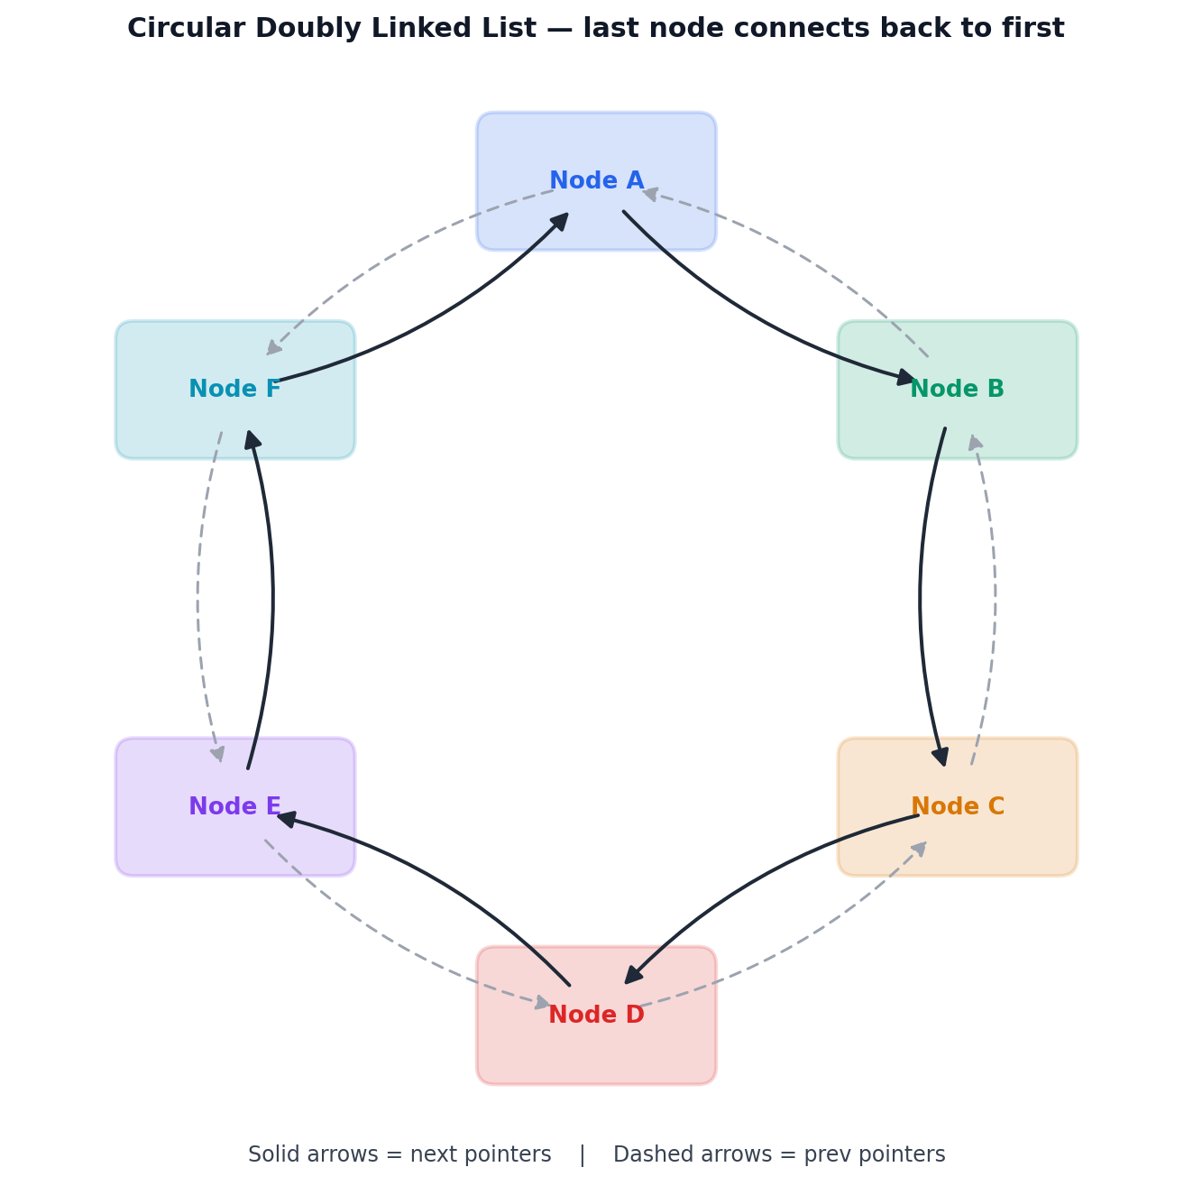
Fig 2: Circular Doubly Linked List — every node links forward (next) and backward (prev), and the last node wraps to the first
Compared to Arrays
- Dynamic size: a circular DLL grows/shrinks at runtime; arrays (static ones) need a pre-defined size and costly resizing/copying when full.
- No memory wastage / no contiguous block requirement: nodes can be scattered in memory, unlike arrays which need one large contiguous block.
- Efficient insertion & deletion: adding/removing a node is O(1) if you have a pointer to it — no shifting of elements as required in arrays (O(n)).
Compared to a Singly Linked List
- Bidirectional traversal: each node has both next and prev pointers, so you can move forward and backward — a singly LL only allows forward traversal.
- O(1) deletion of a given node: with the prev pointer available, a node can be deleted without traversing from the head to find its predecessor (needed in a singly LL).
- Circular nature = continuous traversal: from any node, every other node is reachable without ever needing to reset to the head — perfect for cyclic processes.
- No NULL checks / cleaner looping logic: since the last node points back to the first, traversal loops don't need a special "end of list" NULL check — useful when repeatedly cycling through elements.
Real-world use cases where this matters
- Round-robin CPU scheduling in operating systems — processes are cycled through continuously.
- Music/video playlist "repeat all" — after the last song, playback wraps to the first automatically.
- Multiplayer turn-based games — turn order cycles endlessly among players.
- Browser tab switching (Ctrl+Tab cycling) and undo/redo buffers implemented as circular structures.
- The Josephus problem and other simulation/scheduling algorithms that rely on circular elimination.
💡 Interview Tip: Key one-line answer for interviews: "A circular DLL combines the flexibility of dynamic memory (over arrays) with bidirectional, wrap-around traversal (over singly LL), making it ideal for any continuously cyclic process like scheduling or playlists."
4.Draw a UML class diagram for implementing LRU cache using circular DLL and HashMap

4.Draw a UML class diagram for implementing LRU cache using circular DLL and HashMap.

kkk

JJp.

4.Draw a UML class diagram for implementing LRU cache using circular DLL and HashMap.
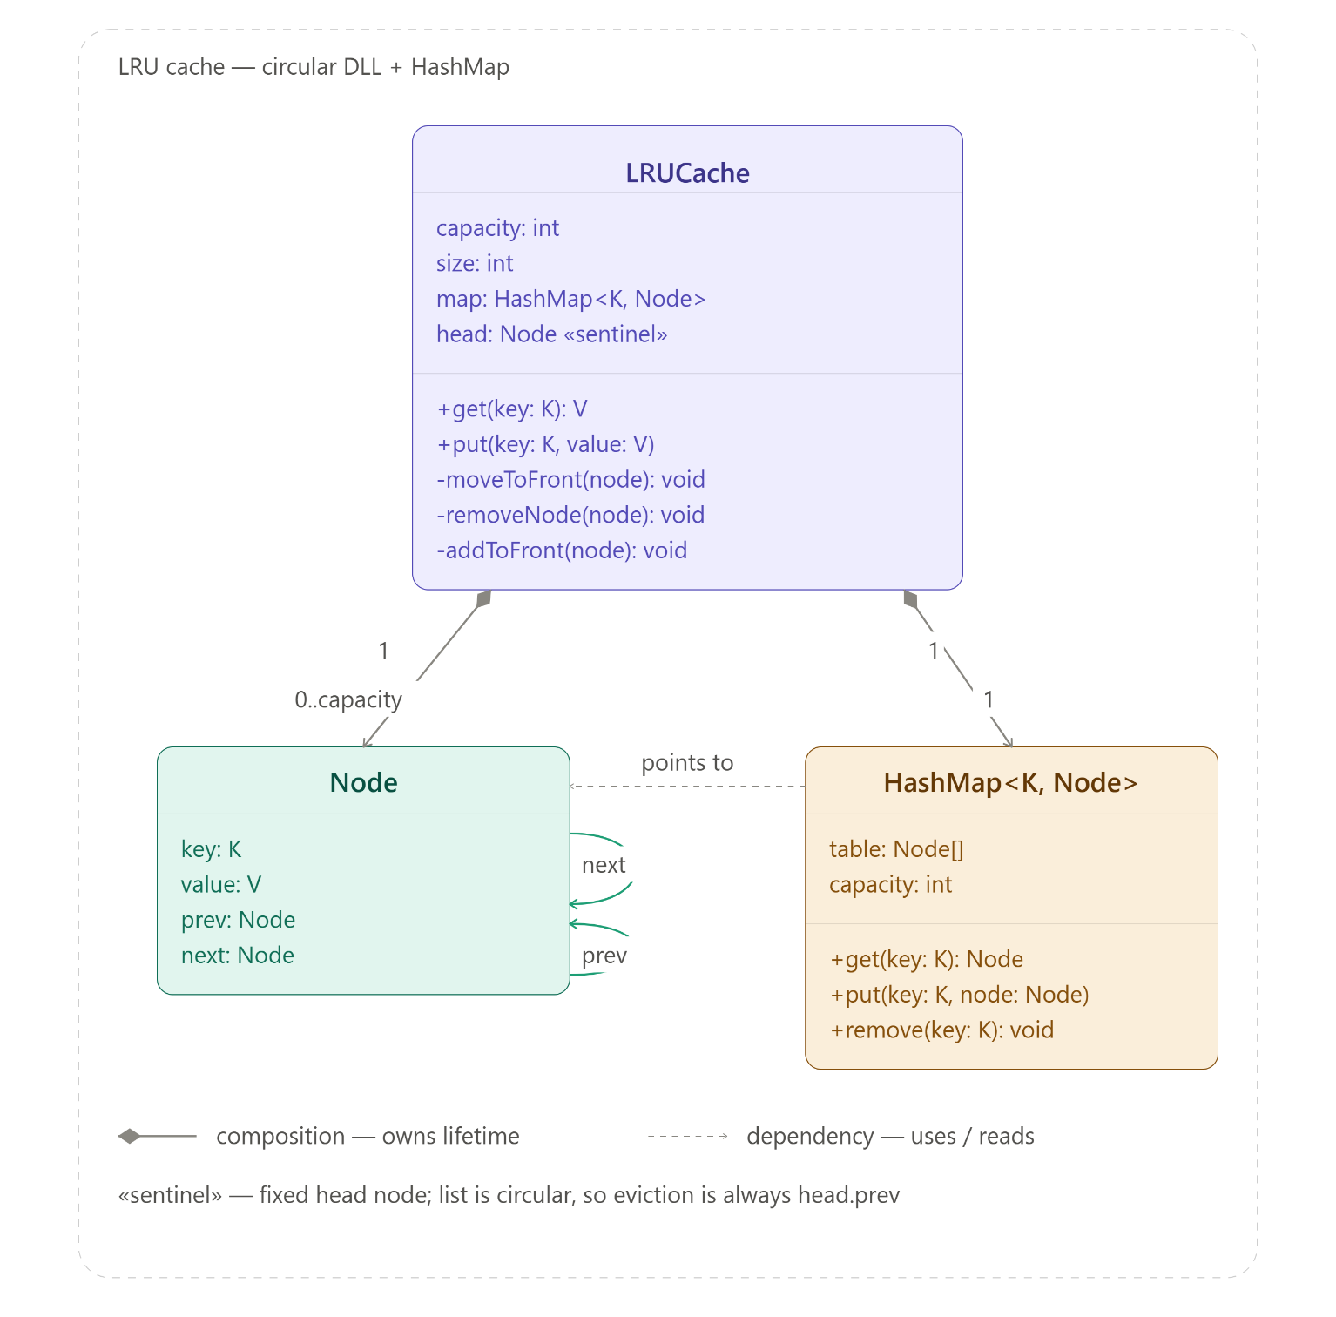
- head is a sentinel, not a real entry. Because the list is circular, head.next is always the most-recently-used node and head.prev is always the least-recently-used one — eviction on a full cache is just removeNode(head.prev), no traversal needed.
- HashMap and the ring are complementary. The map gets you to a node in O(1); the ring gets you from that node to its neighbors in O(1). Neither alone gives you both fast lookup and fast reordering.
- get and put share the same moveToFront/addToFront machinery — a hit just promotes an existing node, a miss creates one and promotes it, keeping the "recently used" logic in one place instead of duplicated per operation.

Q4.Draw a UML class diagram for implementing LRU cache using circular DLL and HashMap

